NAME:G Chinna

REG.NO:192111581

JAVA CSA0998

DAY2:PROGRAMS

Program1:find the average

import java.util.\*;

class average{

public static void main(String[] args){

int a[]=new int[3];

Scanner S=new Scanner(System.in);

int i,sum=0;

float average;

System.out.println("enter marks of students");{

for(i=0;i<3;i++)

a[i]=S.nextInt();

}

for(i=0;i<a.length;i++){

sum=sum+a[i];

}

average=sum/a.length;

System.out.println("average"+average);

}

Output

}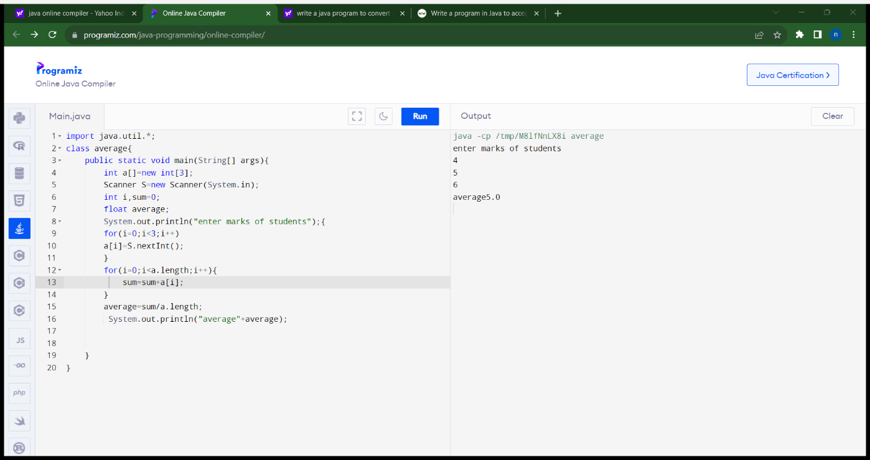

Program2:matrix addition

import java.util.Scanner;

class AddMatrix

{

public static void main(String args[])

{

int row, col,i,j;

Scanner in = new Scanner(System.in);

System.out.println("Enter the number of rows");

row = in.nextInt();

System.out.println("Enter the number columns");

col = in.nextInt();

int mat1[][] = new int[row][col];

int mat2[][] = new int[row][col];

int res[][] = new int[row][col];

System.out.println("Enter the elements of matrix1");

for ( i= 0 ; i < row ; i++ )

{

for ( j= 0 ; j < col ;j++ )

mat1[i][j] = in.nextInt();

System.out.println();

}

System.out.println("Enter the elements of matrix2");

for ( i= 0 ; i < row ; i++ )

{

for ( j= 0 ; j < col ;j++ )

mat2[i][j] = in.nextInt();

System.out.println();

}

for ( i= 0 ; i < row ; i++ )

for ( j= 0 ; j < col ;j++ )

res[i][j] = mat1[i][j] + mat2[i][j] ;

System.out.println("Sum of matrices:-");

for ( i= 0 ; i < row ; i++ )

{

for ( j= 0 ; j < col ;j++ )

System.out.print(res[i][j]+"\t");

System.out.println();

}

}

}

Output:

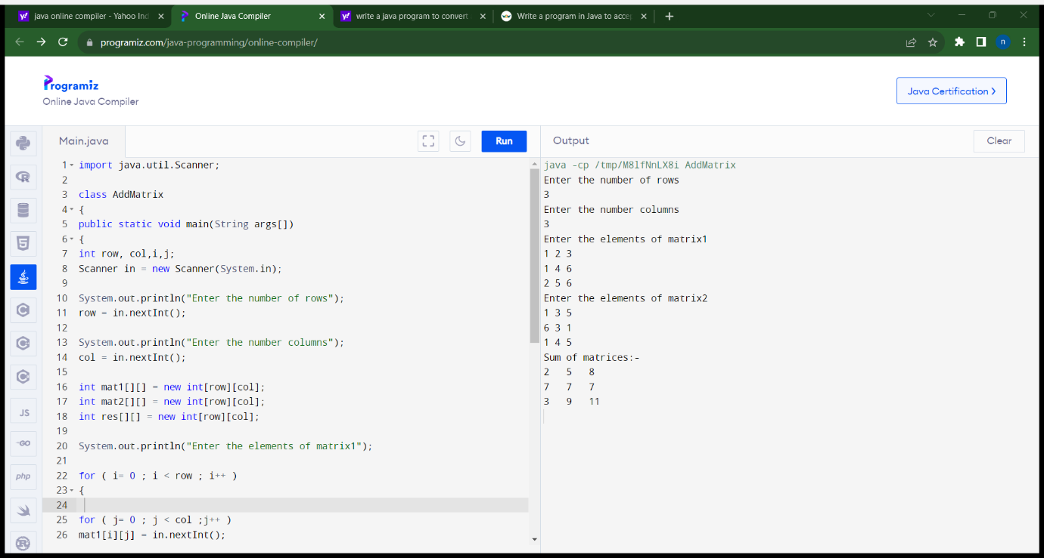

Program3:area of rectangle(method1)

class rectangle

{

void area(int height,int width)

{

int result=height\*width;

System.out.println("area of rectangle is="+result);

}

}

class rect

{

public static void main(String args[])

{

rectangle obj=new rectangle();

obj.area(2,10);

}

}

Output:

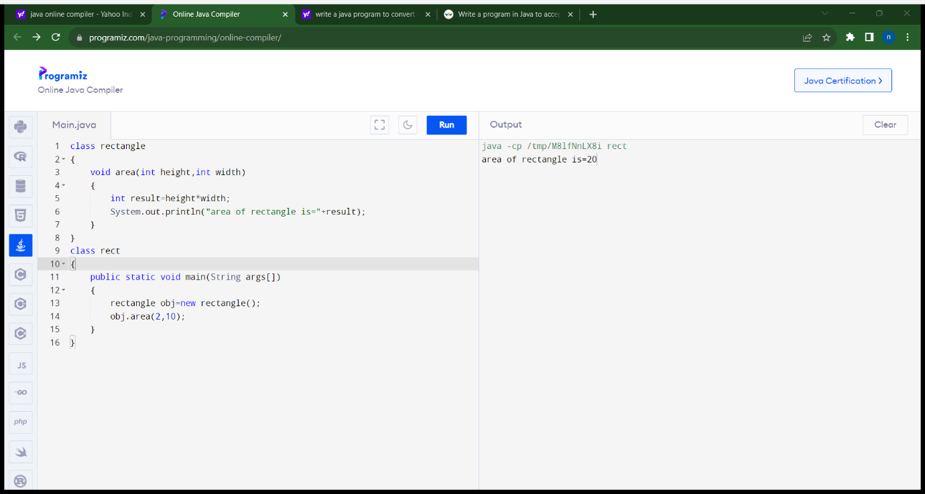

Program4:area of rectangle(method2)

import java.util.\*;

class rectangle

{

int height,width;

void area()

{

Scanner s=new Scanner(System.in);

System.out.println("enter height");

height=s.nextInt();

System.out.println("enter width");

width=s.nextInt();

}

void cal()

{

int result=height\*width;

System.out.println("area of rectangle is="+result);

}

}

class rect

{

public static void main(String args[])

{

rectangle obj=new rectangle();

obj.area();

obj.cal();

}

}

Output:

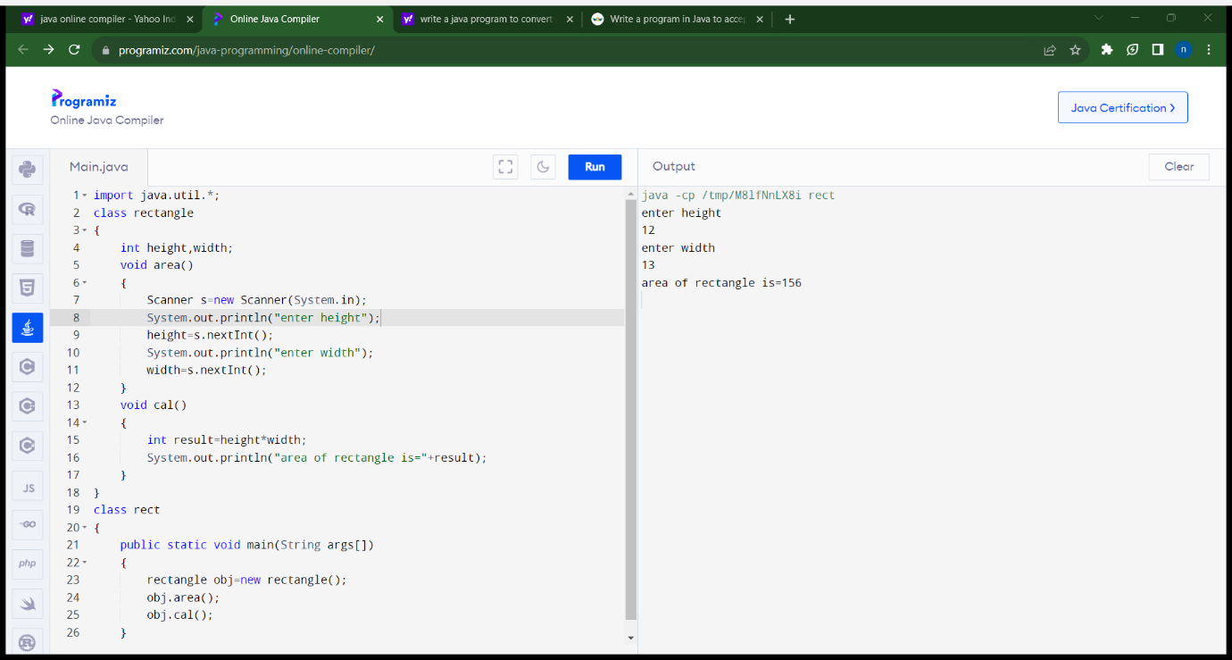

Program5:area of triangle

import java.util.\*;

class triangle

{

int height,breadth;

void area()

{

Scanner s=new Scanner(System.in);

System.out.println("enter height");

height=s.nextInt();

System.out.println("enter breadth");

breadth=s.nextInt();

}

void cal()

{

int result=(height\*breadth)/2;

System.out.println("area of triangle is="+result);

}

}

class rect

{

public static void main(String args[])

{

triangle obj=new triangle();

obj.area();

obj.cal();

}

}

Output:

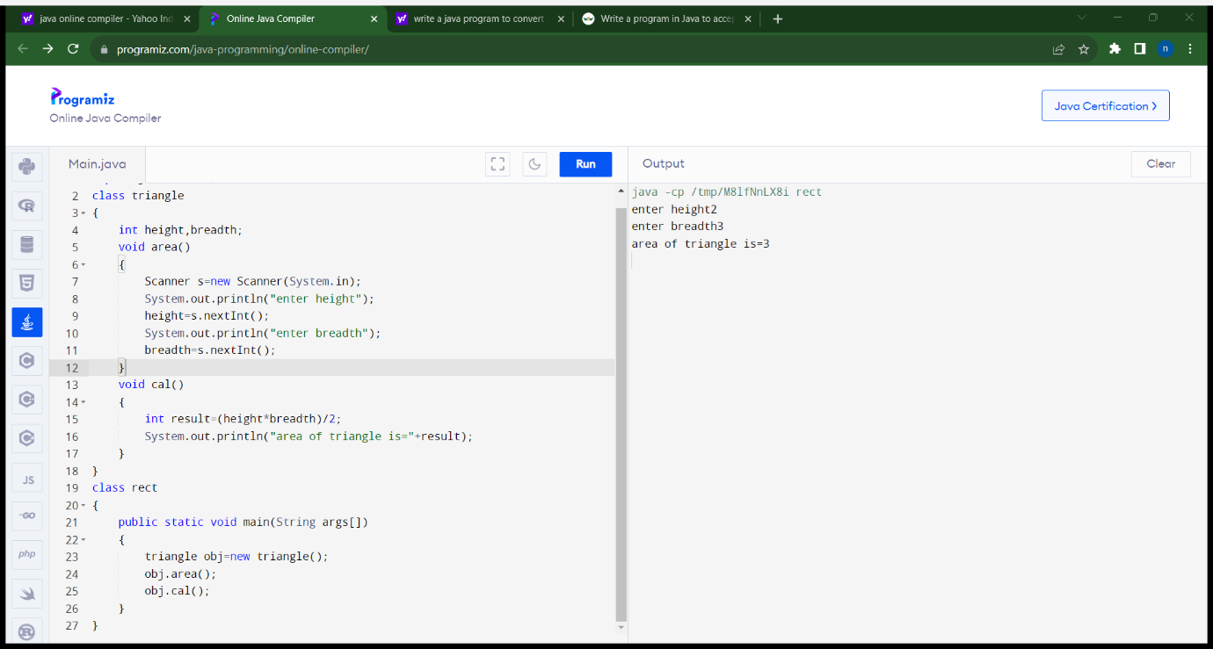

Program6:area of circle

import java.util.\*;

class circle

{

float pi,radius;

void area()

{

Scanner s=new Scanner(System.in);

System.out.println("enter pi");

pi=s.nextFloat();

System.out.println("enter radius");

radius=s.nextFloat();

}

void cal()

{

float result=pi\*radius\*radius;

System.out.println("area of circle is="+result);

}

}

class rect

{

public static void main(String args[])

{

circle obj=new circle();

obj.area();

obj.cal();

}

}

Output:

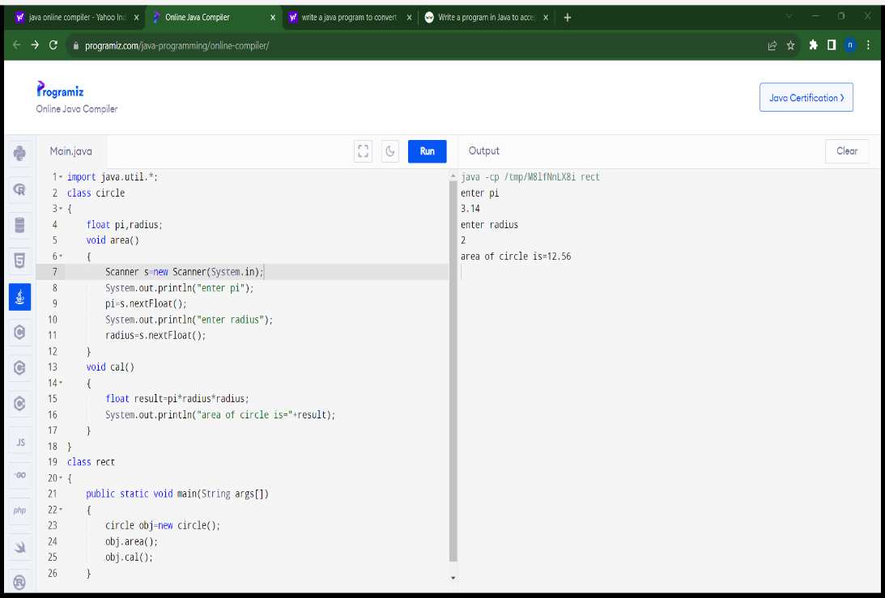

Program7:area of circle(constructor)

import java.util.\*;

class circle

{

float pi,radius;

circle()

{

Scanner s=new Scanner(System.in);

System.out.println("enter pi");

pi=s.nextFloat();

System.out.println("enter radius");

radius=s.nextFloat();

}

void cal()

{

float result=pi\*radius\*radius;

System.out.println("area of circle is="+result);

}

}

class rect

{

public static void main(String args[])

{

circle obj=new circle();

obj.cal();

}

}

Output:



Program8:area of triangle(constructor)

import java.util.\*;

class triangle

{

int height,breadth;

triangle()

{

Scanner s=new Scanner(System.in);

System.out.println("enter height");

height=s.nextInt();

System.out.println("enter breadth");

breadth=s.nextInt();

}

void cal()

{

int result=(height\*breadth)/2;

System.out.println("area of triangle is="+result);

}

}

class rect

{

public static void main(String args[])

{

triangle obj=new triangle();

obj.cal();

}

}

Output:



Program9:simple interest

import java.util.\*;

class simpleinterest

{

int p,r,t;

void simple()

{

Scanner s=new Scanner(System.in);

System.out.println("enter amount");

p=s.nextInt();

System.out.println("enter rate of interest");

r=s.nextInt();100

System.out.println("enter no of Years");

t=s.nextInt();

}

void cal()

{

int result=(p\*r\*t)/100;

System.out.println("simple interest="+result);

}

}

class rect

{

public static void main(String args[])

{

simpleinterest obj=new simpleinterest();

obj.simple();

obj.cal();

}

}

Output:

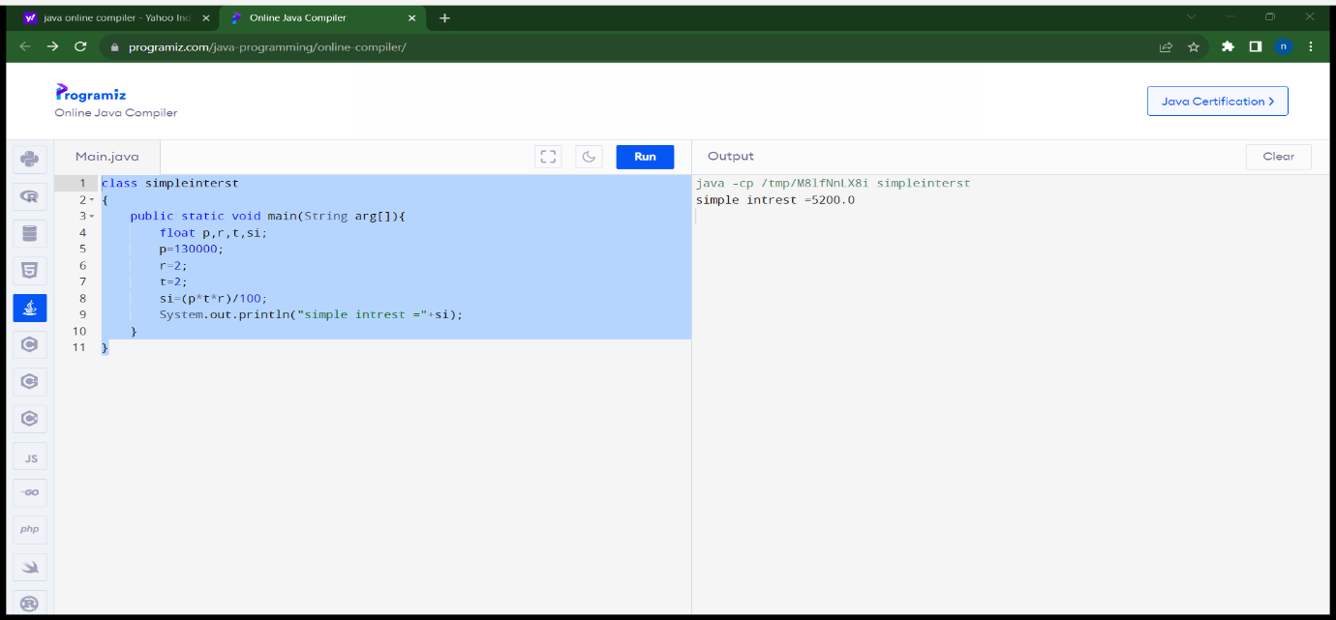

Program10:sum of series

import java.util.\*;

class sumofseries

{

int i,n;

void sum()

{

Scanner s=new Scanner(System.in);

System.out.println("enter n value");

n=s.nextInt();

}

void cal()

{

int sum=0;

for(i=1;i<=n;i++)

{

sum=sum+i;

}

System.out.println("sum of series="+sum);

}

}

class rect

{

public static void main(String args[])

{

sumofseries obj=new sumofseries();

obj.sum();

obj.cal();

}

}

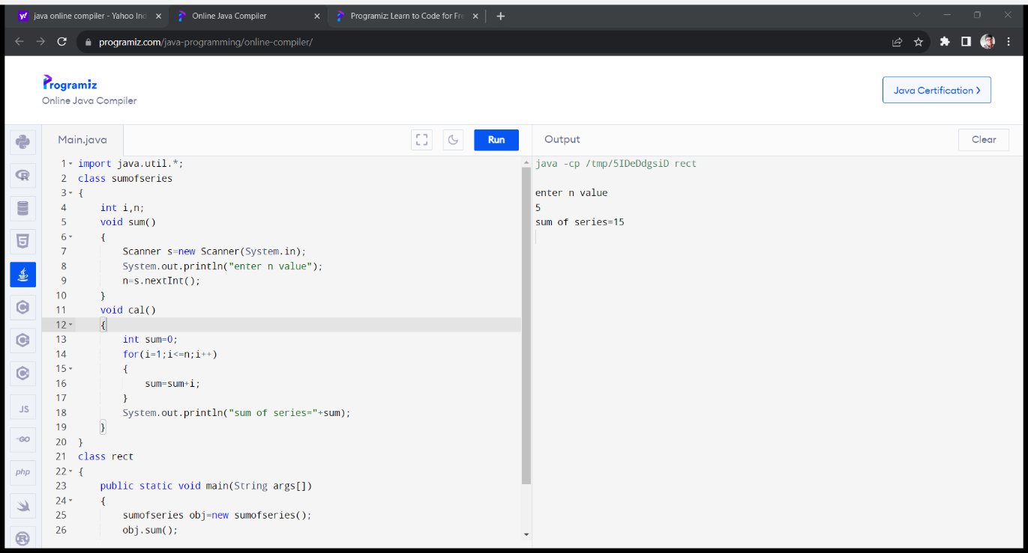

ASSIGNMENT-2

PROGRAM1:

public class Account {

private double balance;

private double interestRate;

public Account(double initialBalance) {

this.balance = Math.max(initialBalance, 0);

this.interestRate = 0.02;

}

public void deposit(double amount) {

if (amount > 0) {

balance += amount;

System.out.println("$" + amount + " deposited successfully.");

} else {

System.out.println("Invalid deposit amount.");

}

}

public void withdraw(double amount) {

if (amount > 0) {

if (amount <= balance) {

balance -= amount;

System.out.println("$" + amount + " withdrawn successfully.");

} else {

System.out.println("Insufficient funds. $5 penalty charged.");

balance -= 5; // Charge a $5 penalty

}

} else {

System.out.println("Invalid withdrawal amount.");

}

}

public double getBalance() {

return balance;

}

public void computeInterest() {

double interest = balance \* interestRate;

balance += interest;

System.out.println("Interest of $" + interest + " applied. Current balance: $" + balance);

}

public static void main(String[] args) {

Account myAccount = new Account(1000);

myAccount.deposit(500);

myAccount.withdraw(300);

myAccount.computeInterest();

double currentBalance = myAccount.getBalance();

System.out.println("Current balance: $" + currentBalance);

}

}

OUTPUT:

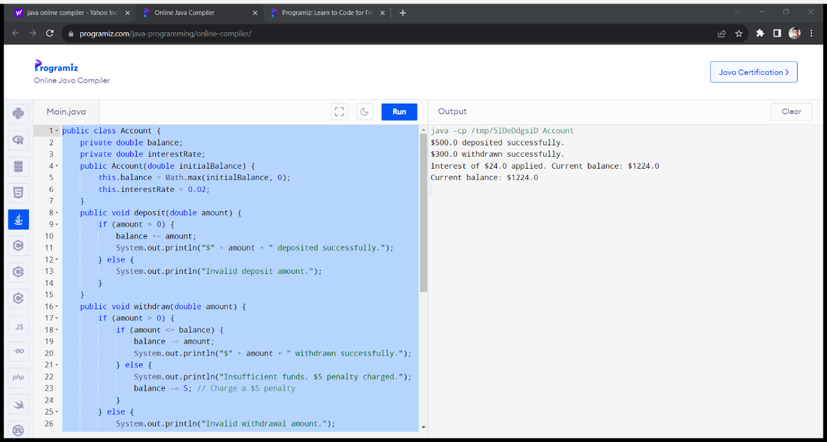

PROGRAM2:

public class Triangle {

private double side1;

private double side2;

private double side3;

public Triangle(double side1, double side2, double side3) {

this.side1 = side1;

this.side2 = side2;

this.side3 = side3;

}

public boolean isRight() {

return (Math.pow(side1, 2) + Math.pow(side2, 2) == Math.pow(side3, 2)

|| Math.pow(side1, 2) + Math.pow(side3, 2) == Math.pow(side2, 2)

|| Math.pow(side2, 2) + Math.pow(side3, 2) == Math.pow(side1, 2));

}

public boolean isScalene() {

return !isIsosceles();

}

public boolean isIsosceles() {

return (side1 == side2 || side1 == side3 || side2 == side3);

}

public boolean isEquilateral() {

return (side1 == side2 && side1 == side3);

}

public static void main(String[] args) {

Triangle triangle = new Triangle(3, 4, 5);

System.out.println("Is right triangle? " + triangle.isRight());

System.out.println("Is scalene triangle? " + triangle.isScalene());

System.out.println("Is isosceles triangle? " + triangle.isIsosceles());

System.out.println("Is equilateral triangle? " + triangle.isEquilateral());

}

}

OUTPUT:

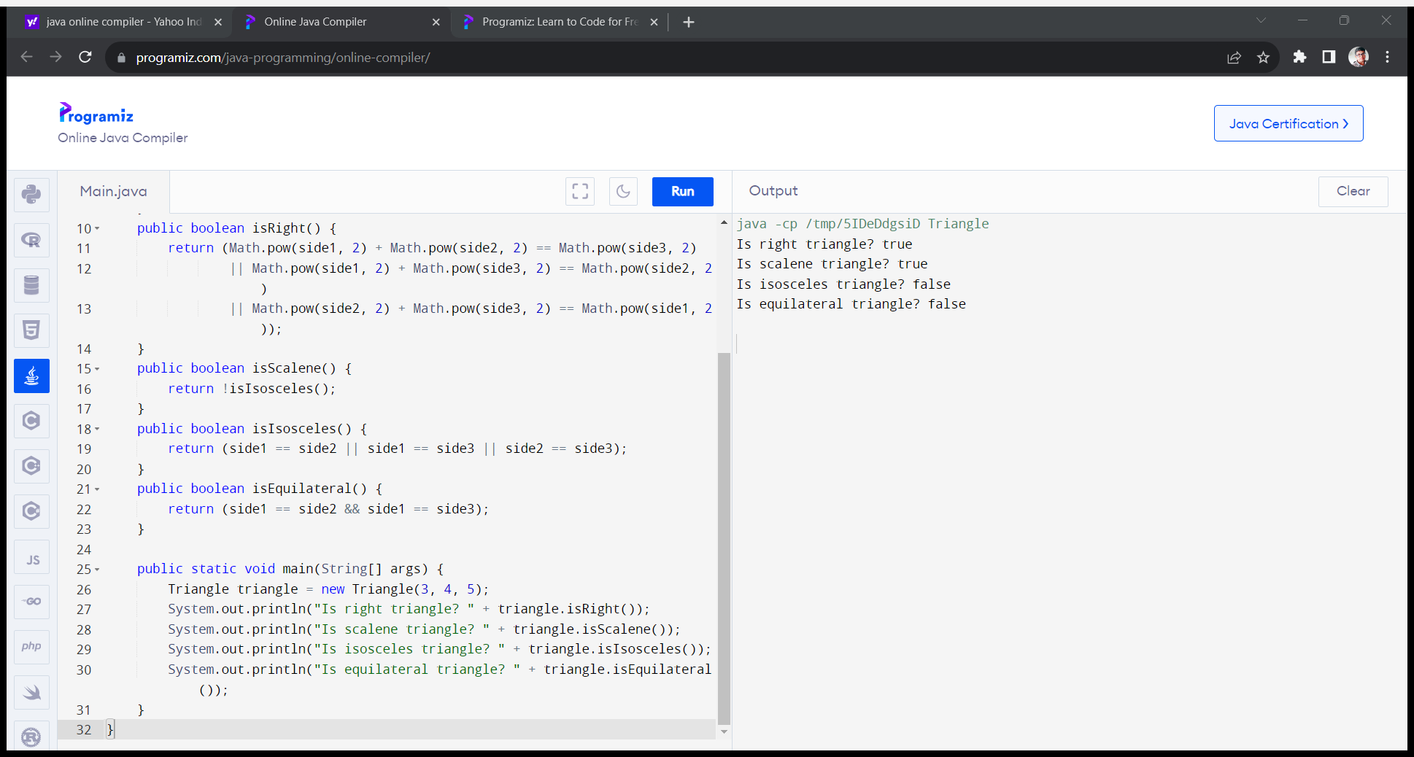

PROGRAM 3

public class MatrixMultiplication {

public static void main(String[] args) {

int[][] mat1 = {

{1, 2},

{5, 3}

};

int[][] mat2 = {

{2, 3},

{4, 1}

};

int[][] result = multiplyMatrices(mat1, mat2);

System.out.println("Mat Sum = ");

for (int i = 0; i < result.length; i++) {

for (int j = 0; j < result[0].length; j++) {

System.out.print(result[i][j] + " ");

}

System.out.println();

}

}

public static int[][] multiplyMatrices(int[][] mat1, int[][] mat2) {

int rows1 = mat1.length;

int cols1 = mat1[0].length;

int rows2 = mat2.length;

int cols2 = mat2[0].length;

if (cols1 != rows2) {

throw new IllegalArgumentException("Matrix dimensions are not compatible for multiplication");

}

int[][] result = new int[rows1][cols2];

for (int i = 0; i < rows1; i++) {

for (int j = 0; j < cols2; j++) {

int sum = 0;

for (int k = 0; k < cols1; k++) {

sum += mat1[i][k] \* mat2[k][j];

}

result[i][j] = sum;

}

}

return result;

}

OUTPUT:

